- Course Title:
  - Lean QA: Much more cost-effective Quality Assurance methods, than testing.
- Course Introduction:
  - THE PROBLEM: testing costs too much, but is in fact ineffective. There are many proven methods for ensuring much better qualities, much sooner. But testers cannot be held responsible for deploying them. This is a CIO, CTO, QA-manager responsibility.
  - Our ´lean´ methods operate upstream, up front, pro-active, and with rapid learning.
  - OUR SOLUTION: We present a powerful selection of methods that can help you help to improve your software qualities dramatically, at low cost. All are freely adoptable. All can be tailored to your development environment immediately. All of them give measurable improvements.
  - Many real stakeholders have to be considered in QA. Not just the ‘user’ and ‘customer’ or the ´tester.
  - You can expect dozens of simple, but deep, and true, nuggets of real practical wisdom – from long experience and first hand practice.
  - You will not get re-iteration of conventional wisdom. You will get deep principles and methods that really work.
  - You will get the benefit of our decades of real experience internationally at IBM, HP, Boeing, Citigroup, JP Morgan, Credit Suisse, Siemens, Ericsson, Nokia, Philips, Rolls Royce, Intel and other top corporations.
  - This course is fact-based, on real life cases, of the lecturers, and others.
- Instructor References:
  - "Tom Gilb invented Evo, arguably the first Agile process. He and his son Kai have been working with me in Norway to align what they are doing with Scrum.” “Kai has some excellent case studies where he has acted as Product Owner. He has done some of the most innovative things I have seen in the Scrum community." : Jeff Sutherland, co-inventor of Scrum

  - “To be valuable, quality requirements must be testable, and hence measurable. There is a technique to quantify qualitative statements called Planguage´, that works wonders on quality requirements. This technique is easy to learn and use, and provides many benefits [Gilb, Competitive Engineering, 2005] Planguage is a keyword-driven specification language that improves communication about complex ideas. Though designed for more general purposes, Planguage excels at quantifying qualitative statements like quality requirements.” Erik Simmons, Intel.

  - “Keep on with the good courses. Your course is widely praised in Nokia” Lars Behrendt, Nokia.

  - “Hi Tom I was instrumental in getting you into Boeing at the time and we trained over 500 engineers from what you (and I and a few others) started You taught a one week course on 'inspection' and we applied it to drawings, software, hard parts, etc . I managed software groups when I was there and was able to produce almost defect free software using OOA&D and inspections. Your 'One Page Standard' is still one of my mantras.
  - Keep it up. Your work has been a great contribution to our so-called engineering field.” Michael Develle, BAE.
  - 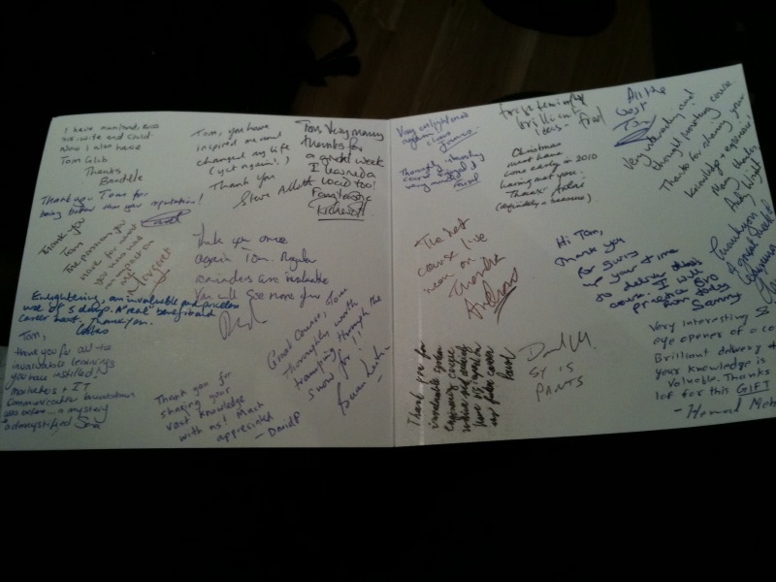
  - London, 2010, One Weeks Course. Participant Thank you notes.
- You will learn about:
  - STAKEHOLDER QUALITY: Stakeholder quality analysis and specification.
  - QUALITY QUANTIFICATION: All quality requirements need to be quantified, to reflect all critical quality dimensions.
  - QUALITY BY DESIGN: Design Quality In! Don’t try to test it in. How to find and evaluate designs that give us needed quality levels. How to estimate impact of designs and architectures on requirement levels, as the basis for ‘assuring’ that we have later reached planned quality levels. Smart architecture for quality.
  - QUALITY DECISION TABLES: a practical tool for managing multiple qualities, multiple costs, and multiple architecture and strategy options - quantitatively and objectively.
  - AGILE QC: Establish ‘agile quality control’, a quantified simple review process. This includes measuring the quality of requirements, designs, code, test plans. It will give people strong motivation to follow best standards practices.
  - QUANTIFIED QUALITY PROCESS GATES: Quantified Process Entry and Exit Control, to drive learning, and practice, of your standards.
  - QUALITY BY FEEDBACK: Evolutionary Product Quality Development: one step above conventional ‘agile’ in dealing with quality. The Unity (111111) method for decomposing architecture into high quality increments.

- Who Should Attend?
  - Methods and Process Responsible for IT, CTO, CIO. Anybody concerned with making sure their development process really delivers proven measurable business value and quality early. Test and QA Managers who are ready to extend their vocabulary.

- Certification:
  - Participants will receive ‘Lean QA Trained’ Certification

- About the Instructors:
  - Kai Gilb: has practiced and innovated these advanced software engineering methods for 2 decades, internationally and in Norway. Some of his clients are Rolls Royce, HP, Siemens Healthcare, Citigroup, Credit Suisse, JP Morgan, Philips Medical Systems, Confirmit (Norway), NTNU IT (Norway), Bring (Norway Post Office), Schlumberger.
  - Tom Gilb: joined IBM Norway in 1958, and formed his consultancy 1960. He is the author of 9 books. He was senior author of Software Inspection (1993, in 14th printing), and published Competitive Engineering (2005, 3rd printing)
  - Both Gilbs invent methods as necessary, and try them out at real clients over a long period, measurably. They do not copy other peoples vague and unproven ideas. They are very specific, and deeply knowledgeable – which is why they have proven documented practice and success, at the worlds most advanced technology companies.
  - More at www.Gilb.com/about

- Books and Papers by the Instructors:
  - See www.Gilb.com/downloads for many papers, case studies, slides, books freely downloadable.
  - For a view of Lean QA see:
    - Lean QA Javazone and Unicom Sept 2010
    - http://www.gilb.com/tiki-download_file.php?fileId=437
    - Lean QA Javazone 2010 Video Tom and Kai
    - http://www.gilb.com/tiki-download_file.php?fileId=362
    - Real QA Paper (1 page)
    - http://www.gilb.com/tiki-download_file.php?fileId=286
    - QA Manifesto (short, 6 pages)
    - http://www.gilb.com/tiki-download_file.php?fileId=285
    - Quality Manifesto & “Software Quality is a Systems Engineering Job”, (Long Paper), at TestingExperience.com, 2008
    - http://www.gilb.com/tiki-download_file.php?fileId=288

- Related Courses and news:
  - The same instructors will hold “Value Scrum: Advanced Front End for Scrum, to focus on delivering quantified value streams to the organization’s stakeholders.
  - March 7-9th 2010 Programutvikling, Oslo

